

**KENTUCKY**

**COOPERATIVE EXTENSION**

..!.! ...

UK .MARTIN•GATTON COLLEGE OF AGRICULTURE. FOOD AND ENVIRONMENT

KSU COLLEGE OF AGRICULTURE. COMMUNITY AND THE SCIENCES

hosted by Liz's Barn Quilts 6 Carlisle County Extension Service

2

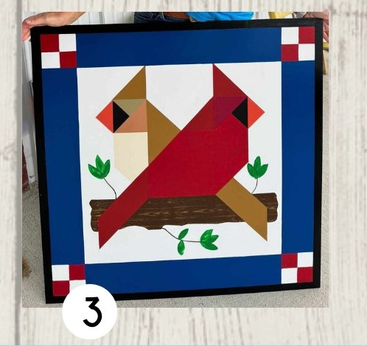Thursda , October 17

# Carlisle Count Extension Office Communit Room

**9AM-3PM**

Space is limited, call to register

**270-628-5Ll58**

# Outdoor Signs:

**2x2= $130, 3x3=$190**

Price Includes:

* All supplies (boards, brushes. paint, etc.)
* Boards primed and ready to paint
* Paint (colors can be decided day of event)
* Lunch (please advise if you have special dietary needs)

Must be PAID IN FULL b'y'. September 17

Sorry, No refunds on missed event - alternative arrangements will be available.

PLEASE BRING YOUR OWN: drink, hair dryer, and .94" Frog Tape

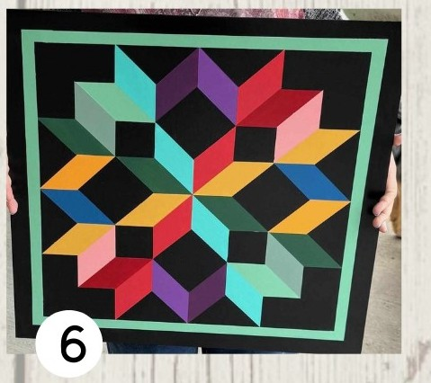

**Cooperative Extension Service**

**MARTIN-GATTON COLLEGE OF AGRICULTURE, FOOD AND ENVIRONMENT**

Educational programs of Kentucky Cooperative Extension serve aH people regardless of economic or social status •

Agriculture and Natural Resources Family and Consumer Sciences

4-H Youth Development

Community and Economic Development

and will not discriminate on the basis of race,color, ethnic origin, national origin.creed, religion, political belief, sex,

sexual orienracion, .gender identity, gender expression, pregnancy, marital status,genetic information. age, veteran status, physical or mental disability or reprisal or retaliation for prior civil rights activity. Reasonable accommodation of disability

may be available with prior notice. Program information may be made available in languages other than English. *,/*

University of Kentucky, Kentucky State University. U.S. Department of Agriculture, and Kentucky Counties. Cooperating.

Lexington. KY 40506

6.

Disabilities

accommodated

with prior notification.